# Rossmoyne Senior High School

### Year 12 Trial WACE Examination, 2015

### Question/Answer Booklet

**SOLUTIONS**

# MATHEMATICS

# 3CD

## Section Two:

## Calculator-assumed

|  |  |  |  |  |  |  |  |  |
| --- | --- | --- | --- | --- | --- | --- | --- | --- |
| Student Number: In figures |  |  |  |  |  |  |  |  |

In words

Your name

## Time allowed for this section

Reading time before commencing work: ten minutes

Working time for this section: one hundred minutes

## Materials required/recommended for this section

##### *To be provided by the supervisor*

This Question/Answer Booklet

Formula Sheet (retained from Section One)

##### *To be provided by the candidate*

Standard items: pens (blue/black preferred), pencils (including coloured), sharpener,

correction fluid/tape, eraser, ruler, highlighters

Special items: drawing instruments, templates, notes on two unfolded sheets of A4 paper, and up to three calculators approved for use in the WACE examinations

## Important note to candidates

No other items may be taken into the examination room. It is **your** responsibility to ensure that you do not have any unauthorised notes or other items of a non-personal nature in the examination room. If you have any unauthorised material with you, hand it to the supervisor **before** reading any further.

## Structure of this paper

|  |  |  |  |  |  |
| --- | --- | --- | --- | --- | --- |
| Section | Number of questions available | Number of questions to be answered | Working time (minutes) | Marks available | Percentage of exam |
| Section One:  Calculator-free | 8 | 8 | 50 | 50 | 33⅓ |
| Section Two:  Calculator-assumed | 13 | 13 | 100 | 100 | 66⅔ |
|  | | | **Total** | 150 | 100 |

## Instructions to candidates

1. The rules for the conduct of examinations are detailed in the school handbook. Sitting this examination implies that you agree to abide by these rules.
2. Write your answers in this Question/Answer Booklet.
3. You must be careful to confine your response to the specific question asked and to follow any instructions that are specified to a particular question.
4. Spare pages are included at the end of this booklet. They can be used for planning your responses and/or as additional space if required to continue an answer.

* Planning: If you use the spare pages for planning, indicate this clearly at the top of the page.
* Continuing an answer: If you need to use the space to continue an answer, indicate in the original answer space where the answer is continued, i.e. give the page number. Fill in the number of the question that you are continuing to answer at the top of the page.

1. **Show all your working clearly**. Your working should be in sufficient detail to allow your answers to be checked readily and for marks to be awarded for reasoning. Incorrect answers given without supporting reasoning cannot be allocated any marks. For any question or part question worth more than two marks, valid working or justification is required to receive full marks. If you repeat any question, ensure that you cancel the answer you do not wish to have marked.
2. It is recommended that you **do not use pencil**, except in diagrams.
3. The Formula Sheet is **not** to be handed in with your Question/Answer Booklet.

Section Two: Calculator-assumed (100 Marks)

This section has**thirteen (****13)** questions. Answer **all** questions. Write your answers in the spaces provided.

Working time: 100 minutes.

Question 9 (6 marks)

The rate of change of concentration of a pollutant in a water reservoir can be expressed by the differential equation , where C is the concentration in parts per million t days after observations began and k is a constant.

The initial concentration of the pollutant was 82 ppm. Two weeks later this value had dropped to 35 ppm.

(a) Determine the value of k, rounding your answer to four significant figures. (3 marks)



(b) Determine the concentration of the pollutant after three weeks. (1 mark)



(c) The water can be used for drinking once the concentration of the pollutant falls below 5 parts per million. Determine how long it will take for the concentration to reach this level.

(2 marks)



Question 10 (10 marks)

The liquid part of a diet is to provide at least 250 calories, 0.48 mg of vitamin A, and 45 mg of vitamin C daily. A cup of drink X provides 50 calories, 0.16 mg of vitamin A and 5 mg of vitamin C. A cup of drink Y provides 50 calories, 0.08 mg of vitamin A and 15 mg of vitamin C.

Let x be the number of cups of drink X consumed daily and y be the number of cups of drink Y consumed daily.

Some of the constraints relating to the above information can be represented by the inequalities , ,  and .

(a) Write one more inequality that applies to this situation, in simplified form. (2 marks)



(b) Draw this inequality on the axes below and shade the feasible region. (2 marks)

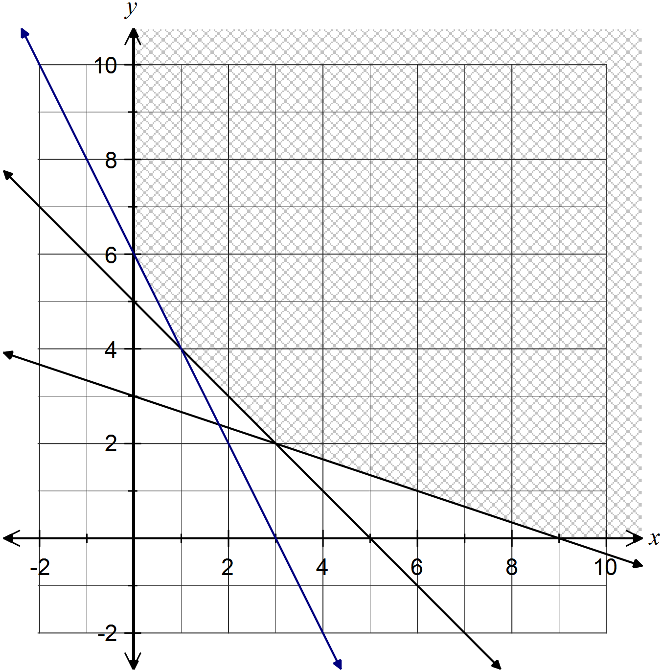

A cup of drink X contains 12 g of sugar and a cup of drink Y contains 15 g of sugar.

(c) Determine the number of cups of each drink that should be consumed on a daily basis to minimize sugar intake and still meet the stated daily requirements. State the minimum sugar intake. (3 marks)

Objective function to minimise is .



Minimum sugar intake is 66 g when 3 cups of X and 2 cups of Y are consumed.

(d) Determine how much the amount of sugar in drink Y can be decreased, whilst still maintaining the optimal solution in (c). (3 marks)

New objective function is  .



Sugar in drink Y can be decreased by up to 3 g per cup to maintain optimal solution.

Question 11 (7 marks)

A team of six is chosen at random from a squad of ten students, two of whom are short-sighted.

(a) Determine the probability that

(i) exactly one of the team members is short-sighted. (2 marks)



(ii) at least one of the team members is short-sighted. (2 marks)



(b) Suppose that 20% of students in a large city are known to be short-sighted. If six of these students are selected at random, determine the probability that

(i) exactly one of the students selected is short-sighted. (2 marks)



(ii) at least one of the students selected is short-sighted. (1 mark)



Question 12 (9 marks)

A vehicle insurance company classifies drivers as high (H), medium (M) or low (L) risk with regard to having an accident. The company estimate that 15% of their drivers are high risk and 35% are low risk. The probability that a high risk driver will have one or more accidents in any given 12 month period is 0.05, with corresponding values for medium and low risk drivers being 0.03 and 0.01.

(a) Determine the probability that a driver selected at random from company records

(i) was classified as medium risk and will not have had an accident in the past year.

(2 marks)



(ii) will have had an accident during the last 12 months. (2 marks)



(iii) was classified as high risk, given they had had an accident during the past year.

(2 marks)



(b) The company randomly select a group of 25 high risk drivers and another group of 25 low risk drivers. Assuming that accidents occur independently of each other, show that the probability that none of the drivers in the low risk group have an accident during the next 12 months is roughly three times the probability that none of the drivers in the high risk group have an accident. (3 marks)



Question 13 (12 marks)

The thickness, x microns, of a protective coating applied to electrical components for use in wet conditions is known to follow a uniform distribution with minimum and maximum values of 350 and 600 microns respectively.

The mean thickness is 475 microns and the standard deviation of x is 72.2 microns.

(a) Sketch the graph of the density function of x. (2 marks)

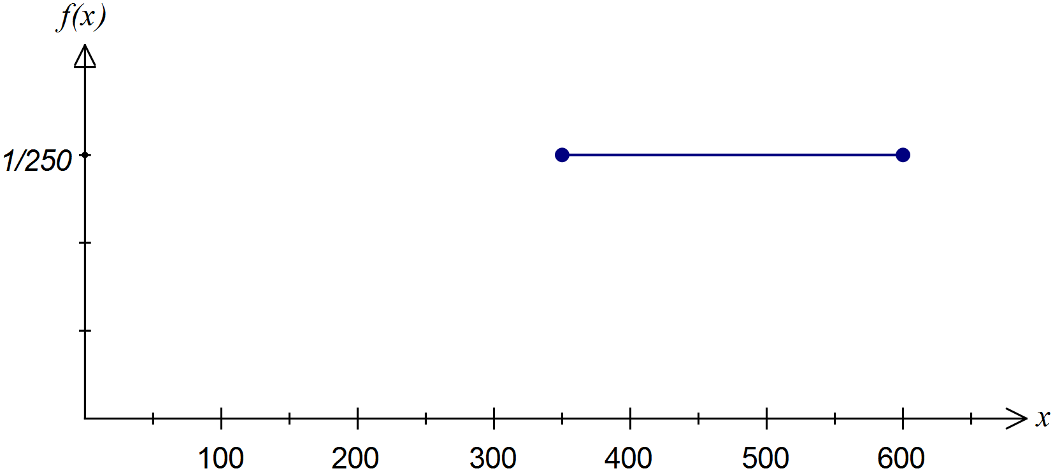

(b) Determine the probability that the thickness of the protective coating of a component

(i) is at least 425 microns. (1 mark)



(ii) is no more than 550 microns, given that it is at least 425 microns. (2 marks)



(c) Determine the probability that in a box of 48 components, no more than six have a coating less than 425 microns. (3 marks)



(d) A random sample of 144 components was selected and the mean thickness of these components was calculated to be 464 microns, less than the expected value of 475 microns.

Assuming the standard deviation of the coating thickness is still 72.7 microns, calculate a 95% confidence interval for the mean thickness of the coating for all components and explain whether this suggests that the mean thickness is not 475 microns. (4 marks)



Since the mean of 475 is contained within the 95% confidence interval, there is no reason to suspect that it has changed.

Question 14 (11 marks)

Analysis of the fuel consumption rate reported by a large number of owners of a particular model of car was observed to be normally distributed with a mean and standard deviation of 9.25 and 1.15 litres per 100 km respectively. The manufacturers claim that this type of car has a fuel consumption of 8.2 litres per 100 km.

(a) What percentage of these cars have a fuel consumption within one litre per 100 km of the manufacturers claim? (2 marks)



(b) In a random sample of 250 cars that are more economical than the manufacturers claim, how many would be expected to have a fuel consumption better than 7 litres per 100 km?

(3 marks)



(c) The fuel gauge of a randomly selected car shows 13.6 litres of fuel remain in the tank. Determine the probability that the car will reach its destination, 170 km away, without running out of fuel. (2 marks)



(d) The fuel consumption of a random sample of 100 cars is recorded. Determine the probability that the sample mean is within one litre per 100 km of the manufacturers claim. (2 marks)



(e) Determine the number of cars required in a sample so that there is a 90% chance that the sample mean is no more than 0.15 litres per 100 km from the population mean. (2 marks)



Question 15 (6 marks)

A motor vehicle slows down from an initial velocity of 25 ms-1 until it is stationary. During this interval, its acceleration t seconds after the brakes were applied is given by  ms-2.

(a) Determine the velocity of the vehicle after four seconds. (3 marks)



(b) Calculate the distance travelled by the vehicle in the time between the brakes being applied and it becoming stationary. (3 marks)



Question 16 (6 marks)

The events A and B are such that , , and . Determine

(a) . (3 marks)



(b) . (1 mark)



(c) . (1 mark)



(d) . (1 mark)



Question 17 (8 marks)

A cylindrical oil drum, of radius r m and height h m, has circular ends constructed from material costing $75 per square metre and sides constructed from material costing $40 per square metre.

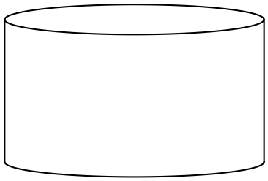

(a) Explain why the cost of construction C, in dollars, is given by .

(1 mark)

TSA of cylinder given by ends plus side:



(b) If the oil drum must be constructed for $250, show that the volume of the oil drum is given by . (3 marks)



(c) Use calculus methods to determine the dimensions that maximise the volume of the oil drum, and state this maximum volume. (4 marks)



Question 18 (7 marks)

The shaded region below is enclosed by the x-axis, the y-axis , the curve , and the tangent to the curve when .

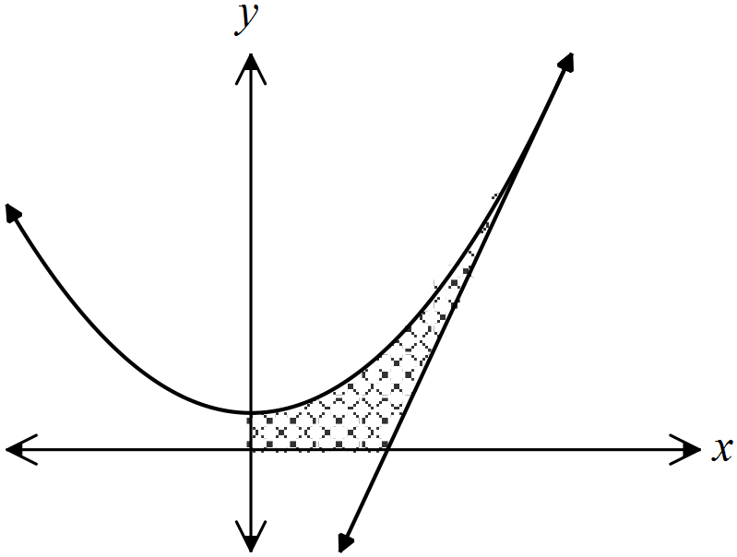

(a) Show that the equation of the tangent to the curve at  is . (2 marks)



(b) Determine the volume of revolution obtained when the shaded region is rotated around the y-axis. (5 marks)



Question 19 (6 marks)

Two sides of the cyclic quadrilateral BCDE are extended to meet at , as shown in the diagram.

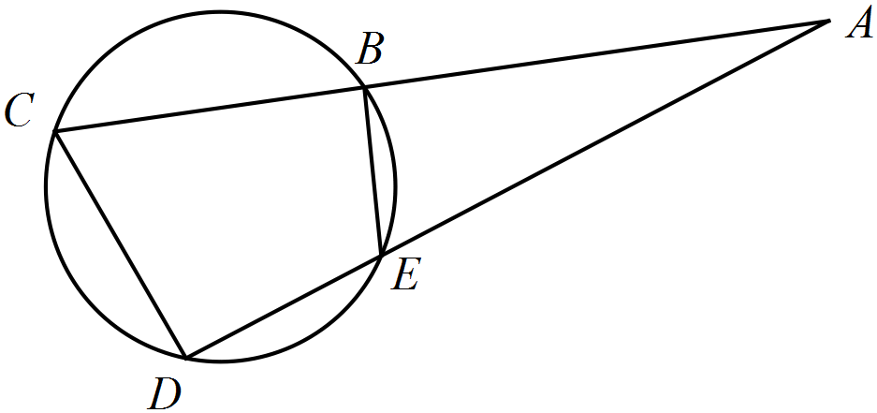

(a) Prove that triangles  and  are similar. (3 marks)



(b) If , determine the lengths of .

(3 marks)



Question 20 (8 marks)

Water is gently poured into an inverted cone of height 30 cm and radius 15 cm at a rate of 36 cm3 per minute. Let h be the height of water in the inverted cone and r the radius of the cone at that point.

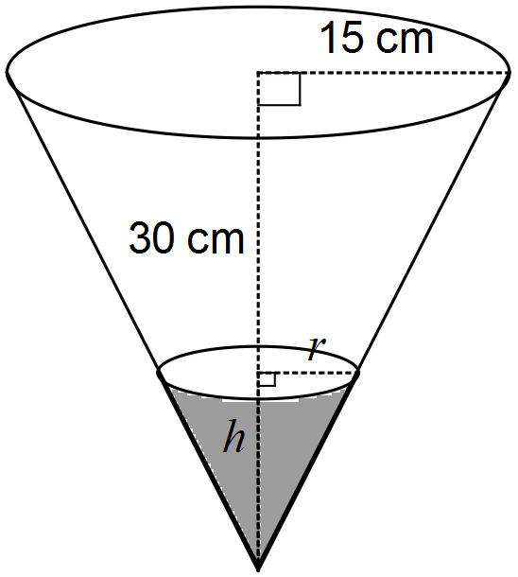

The volume of a cone is given by the formula .

(a) Determine the rate of change of height of the water in the cone at the instant the height reaches 12 cm. (5 marks)



(b) Use the increments formula  to determine the approximate change in volume of water in the cone as the height of water increases from 20 to 20.01 cm. (3 marks)



Question 21 (4 marks)

Given that ,  and , determine the function .



Additional working space

Question number: _________

Additional working space

Question number: _________

Additional working space

Question number: _________

This examination paper may be freely copied, or communicated on an intranet, for non-commercial purposes within educational institutes that have purchased the paper from WA Examination Papers provided that WA Examination Papers is acknowledged as the copyright owner. Teachers within Rossmoyne Senior High School may change the paper provided that WA Examination Paper's moral rights are not infringed.

Copying or communication for any other purposes can only be done within the terms of the Copyright Act or with prior written permission of WA Examination papers.

*Published by WA Examination Papers*

*PO Box 445 Claremont WA 6910*